**Problem Statement**

Predicting players rating In this project you are going to predict the overall rating of soccer player based on their attributes such as 'crossing', 'finishing etc.

The dataset you are going to use is from European Soccer Database (https://www.kaggle.com/hugomathien/soccer) has more than 25,000 matches and more than 10,000 players for European professional soccer seasons from 2008 to 2016.

Download the data in the same folder and run the following commmand to get it in the environment

About the Dataset The ultimate Soccer database for data analysis and machine learning The dataset comes in the form of an SQL database and contains statistics of about 25,000 football matches, from the top football league of 11 European Countries. It covers seasons from 2008 to 2016 and contains match statistics (i.e: scores, corners, fouls etc...) as well as the team formations, with player names and a pair of coordinates to indicate their position on the pitch.

+25,000 matches +10,000 players 11 European Countries with their lead championship Seasons 2008 to 2016 Players and Teams' attributes* sourced from EA Sports' FIFA video game series, including the weekly updates Team line up with squad formation (X, Y coordinates) Betting odds from up to 10 providers Detailed match events (goal types, possession, corner, cross, fouls, cards etc...) for +10,000 matches

The dataset also has a set of about 35 statistics for each player, derived from EA Sports' FIFA video games. It is not just the stats that come with a new version of the game but also the weekly updates. So for instance if a player has performed poorly over a period of time and his stats get impacted in FIFA, you would normally see the same in the dataset.

Python skills required to complete this project

SQL: The data is in SQL database so students need to retrive using query language. They also need to know how to connect SQL database woth python. The library we are using for this in 'sqlite3'.

1/19/2018 ML Project(Updated) (1)

http://localhost:8888/notebooks/20th%20Januray/ML%20Project(Updated)%20(1).ipynb# 2/4

SQLite3 can be integrated with Python using sqlite3 module, which was written by Gerhard Haring. It provides an SQL interface compliant with the DB-API 2.0 specification described by PEP 249. You do not need to install this module separately because it is shipped by default along with Python version 2.5.x onwards.

To use sqlite3 module, you must first create a connection object that represents the database and then optionally you can create a cursor object, which will help you in executing all the SQL statements.

Pandas: Pandas is an open-source, BSD-licensed Python library providing high-performance, easy-to-use data structures and data analysis tools for the Python programming language. Python with Pandas is used in a wide range of fields including academic and commercial domains including finance, economics, Statistics, analytics, etc.In this tutorial, we will learn the various features of Python Pandas and how to use them in practice.

Scikit Learn Scikit-learn provides a range of supervised and unsupervised learning algorithms via a consistent interface in Python.

The library is built upon the SciPy (Scientific Python) that must be installed before you can use scikit-learn. This stack that includes:

NumPy: Base n-dimensional array package SciPy: Fundamental library for scientific computing Matplotlib: Comprehensive 2D/3D plotting IPython: Enhanced interactive console Sympy: Symbolic mathematics Pandas: Data structures and analysis

Extensions or modules for SciPy care conventionally named SciKits. As such, the module provides learning algorithms and is named scikit-learn.

The vision for the library is a level of robustness and support required for use in production systems. This means a deep focus on concerns such as easy of use, code quality, collaboration, documentation and performance.

Machine Learning skills required to complete the project Supervised learning Supervised learning deals with learning a function from available training data. A supervised learning algorithm analyzes the training data and produces an inferred function, which can be used for mapping new examples.

1/19/2018 ML Project(Updated) (1)

http://localhost:8888/notebooks/20th%20Januray/ML%20Project(Updated)%20(1).ipynb# 3/4

Regression Regression is a parametric technique used to predict continuous (dependent) variable given a set of independent variables. It is parametric in nature because it makes certain assumptions (discussed next) based on the data set. If the data set follows those assumptions, regression gives incredible results.

Model evaluation Student must know how to judge a model on unseen data. What metric to select to judge the performance

**Data Set**

Import Libraries

In [1]:

Read Data from the Database into pandas

In [2]:

import sqlite3 import pandas as pd

from sklearn.tree import DecisionTreeRegressor

from sklearn.linear_model import LinearRegression

from sklearn.model_selection import train_test_split

from sklearn.metrics import mean_squared_error

from math import sqrt

# Create your connection.

cnx = sqlite3.connect('database.sqlite')

df = pd.read_sql_query("SELECT * FROM Player_Attributes", cnx

**Solution**

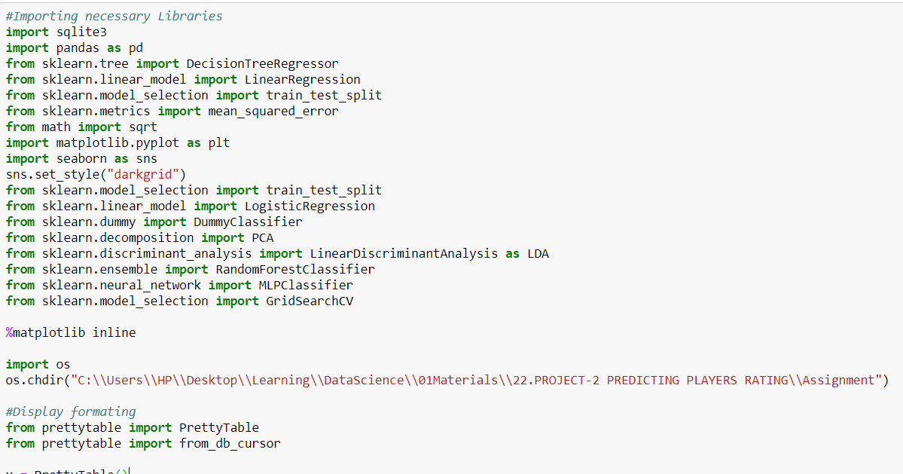

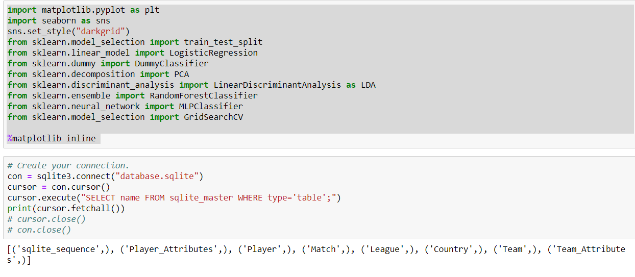

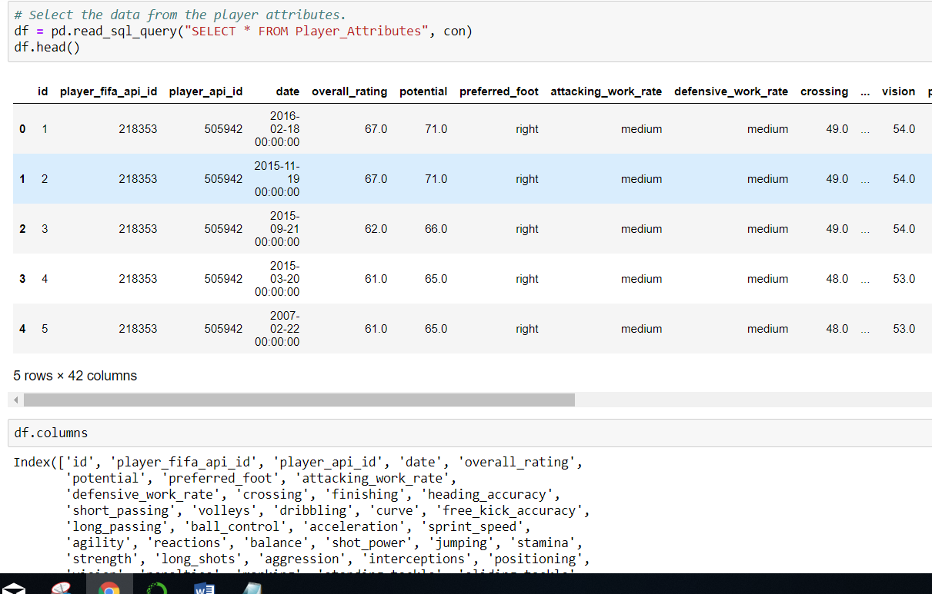

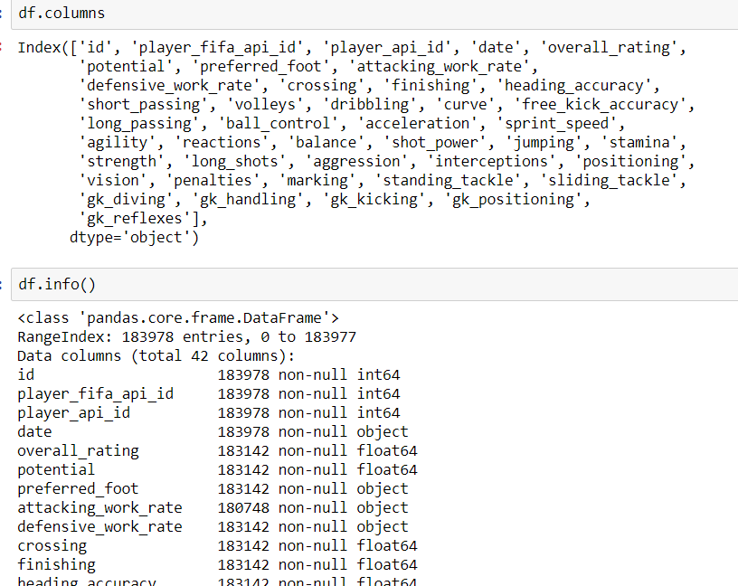

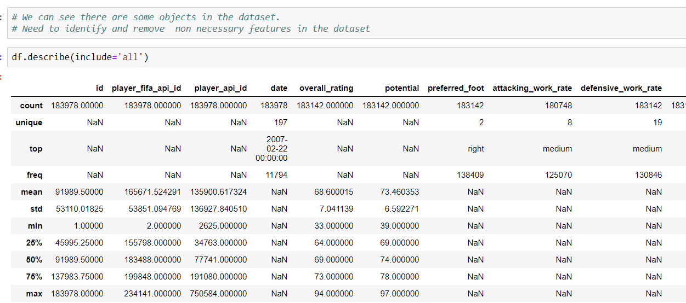

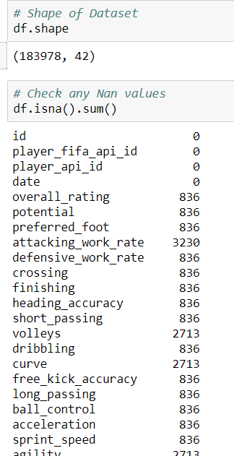

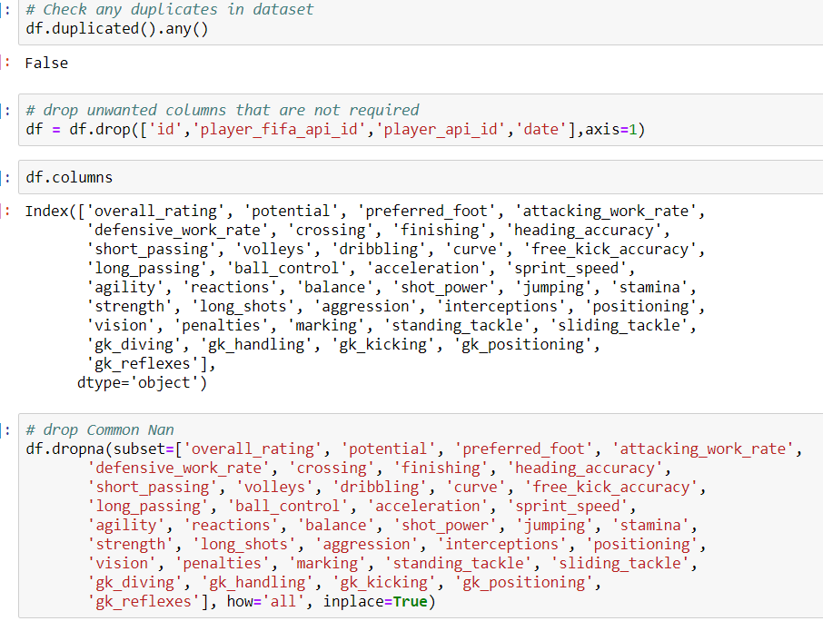

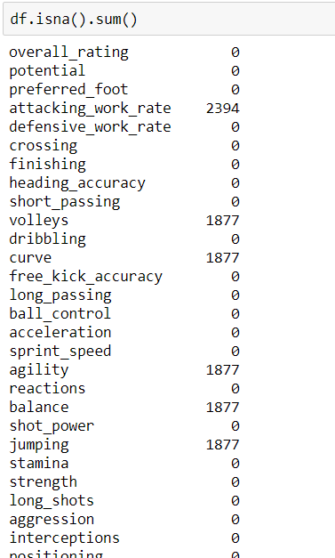

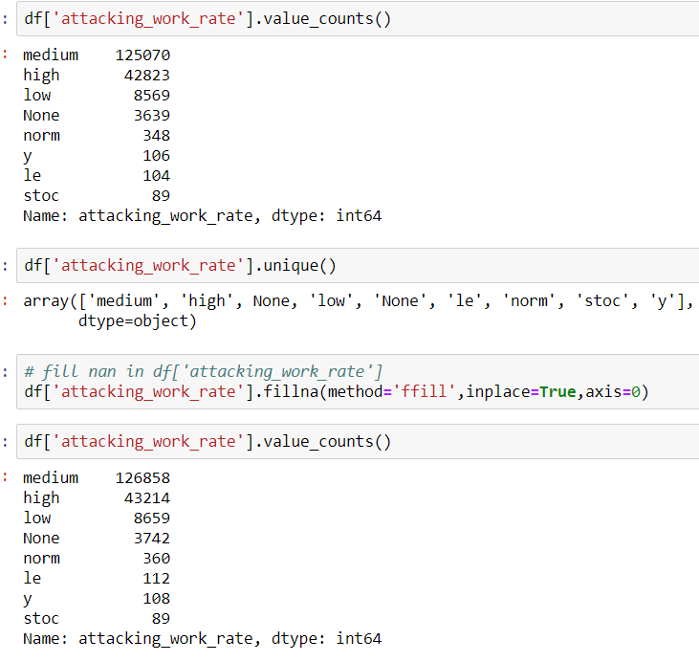

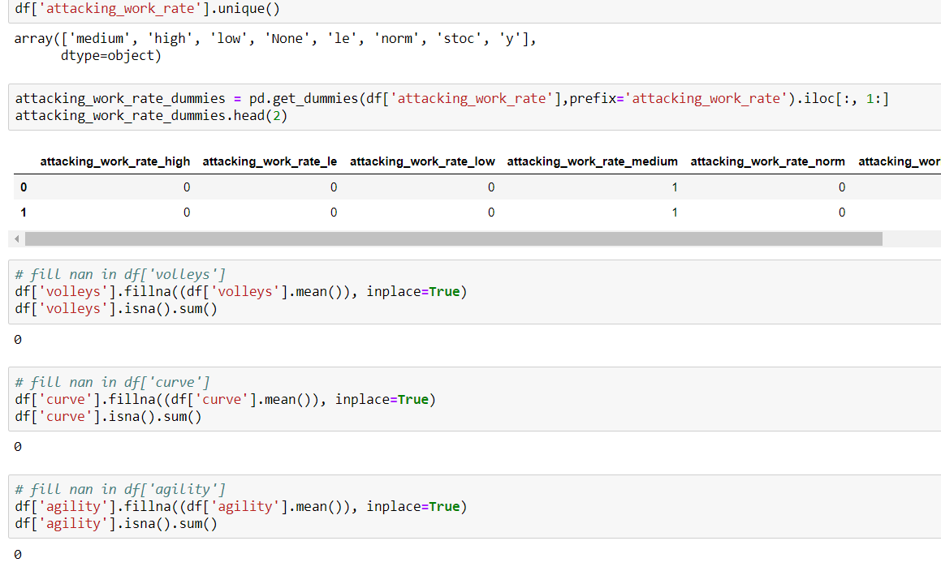

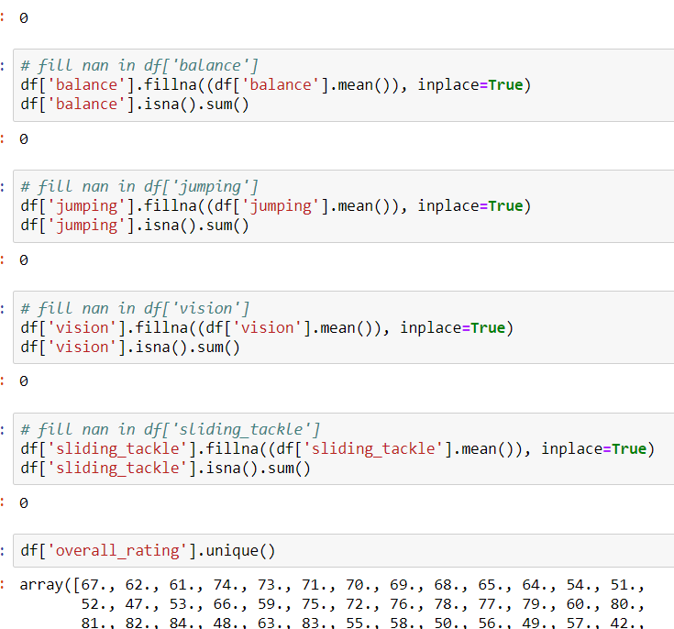

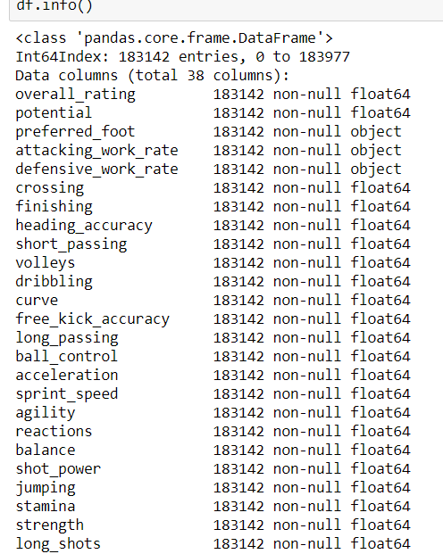

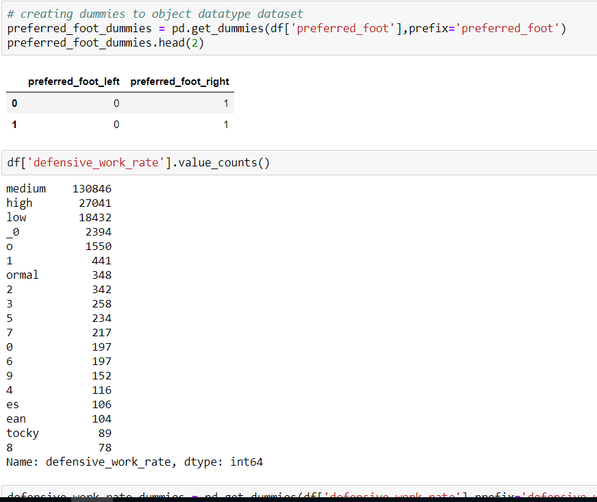

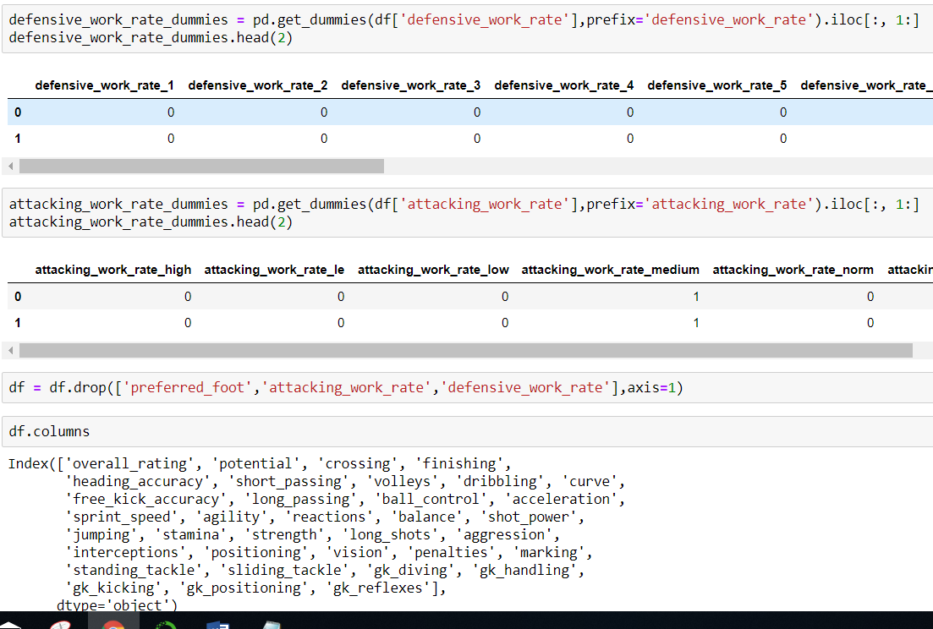

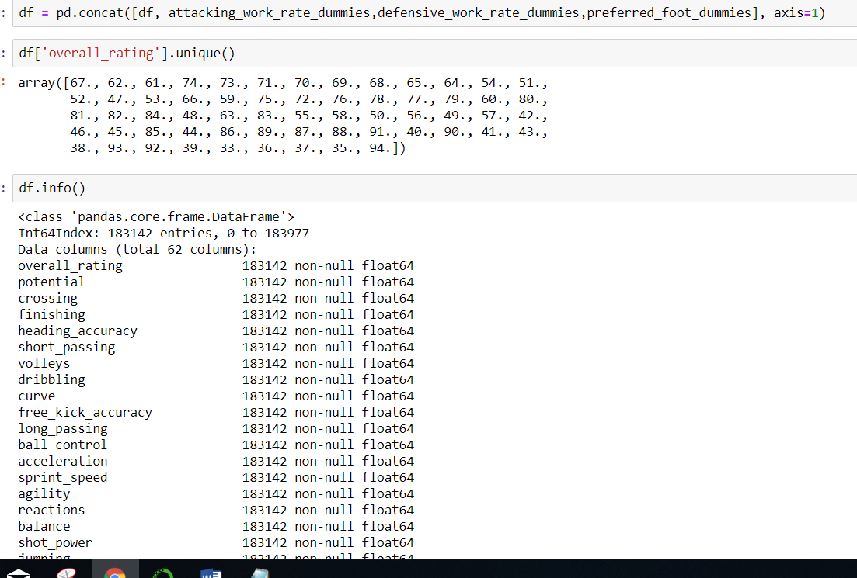

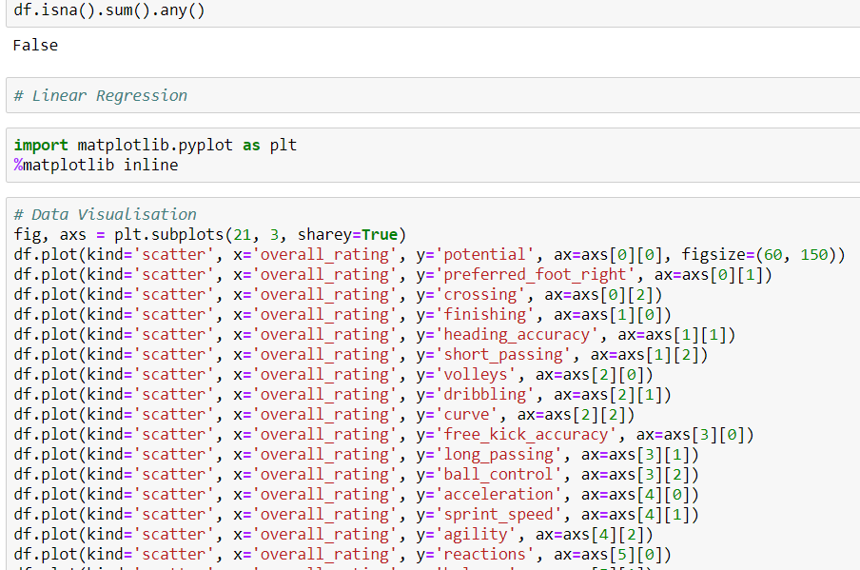

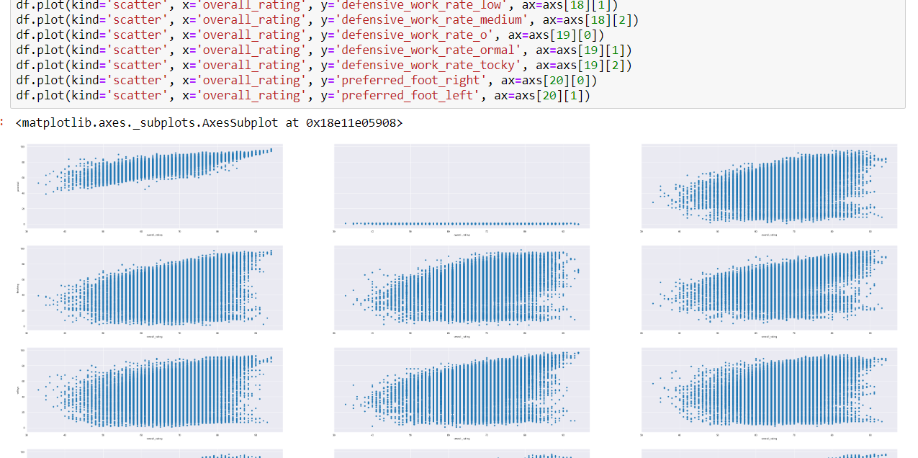

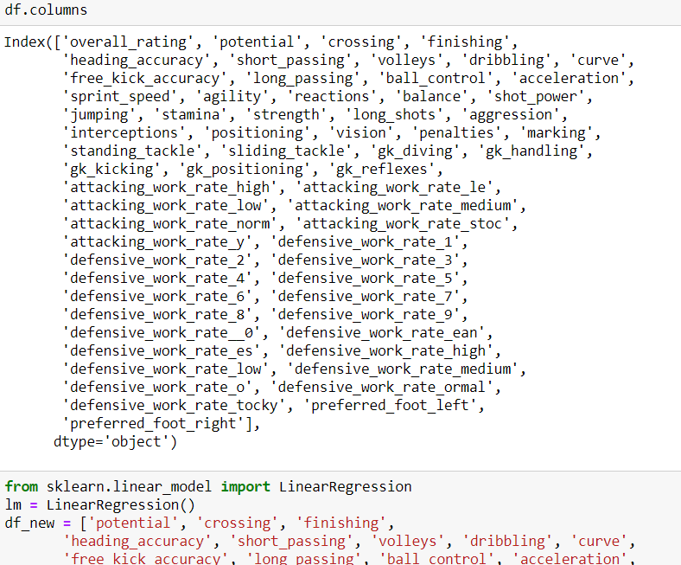

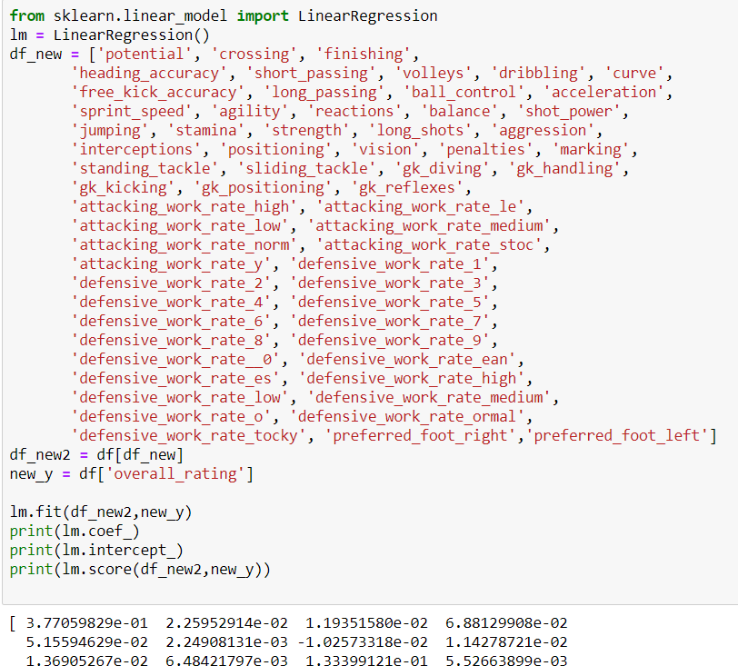

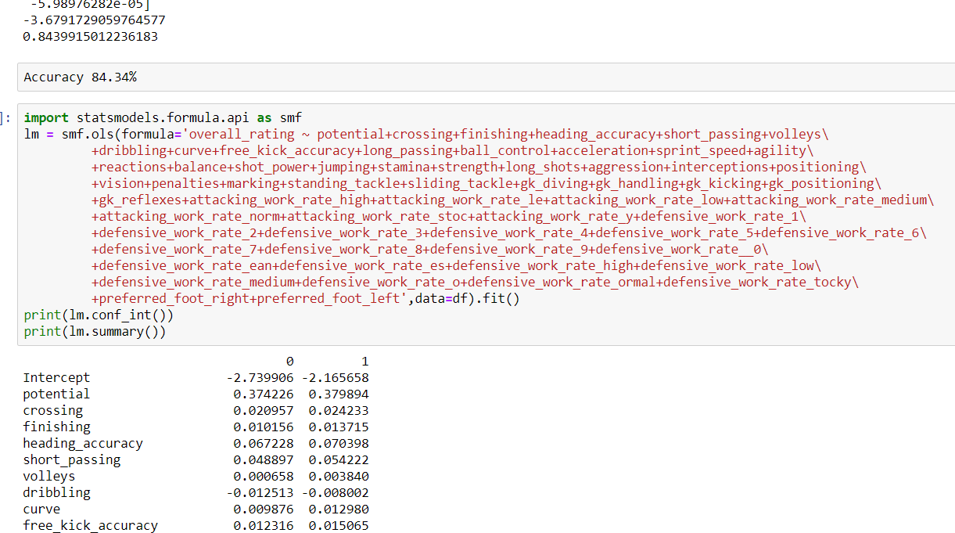

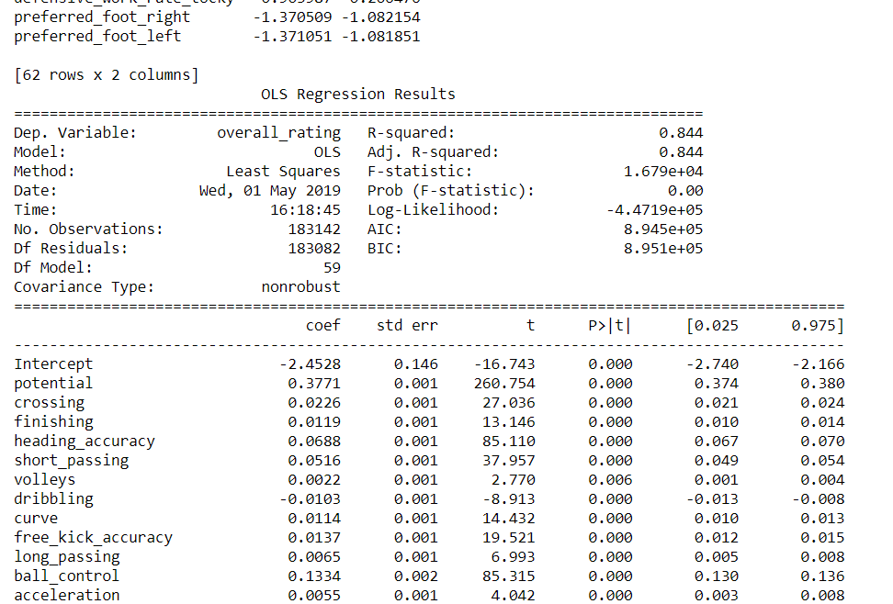

P > 0.05 to be excluded in the model

P>|t|

-------------------------------------

attacking_work_rate_medium 0.074

defensive_work_rate_2 0.142

defensive_work_rate_3 0.065

defensive_work_rate_4 0.093

defensive_work_rate_5 0.251

defensive_work_rate_6 0.667

defensive_work_rate_9 0.113

defensive_work_rate_es 0.062

defensive_work_rate_high 0.885

defensive_work_rate_medium 0.312

defensive_work_rate_o 0.786

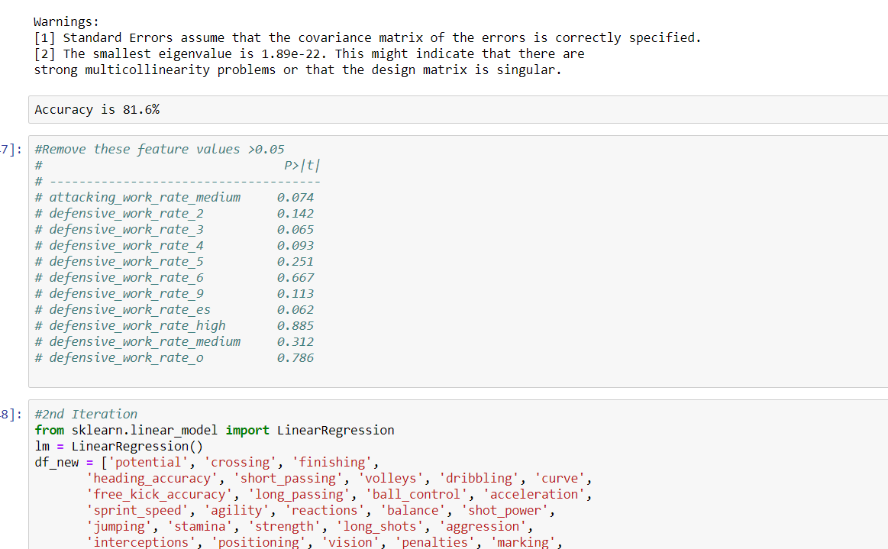

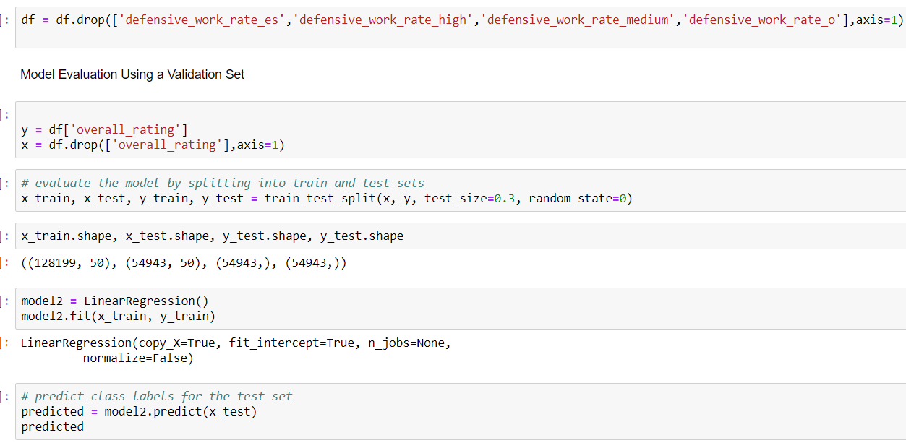

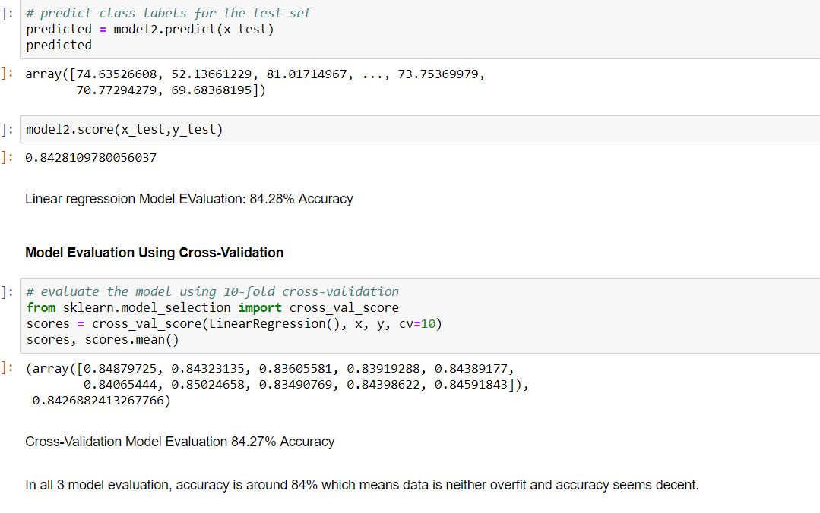

**The accuracy is 84%**